**Reviewing correlations**

1. ***Notation***

$R=\hat{ρ}$: This statement says that $R$ is a *statistic* representing the sample correlation coefficient, which is a *point estimator* of the population correlation coefficient, $ρ$.

$r=\hat{ρ}$: This statement says that $r$,the value of sample correlation coefficient in our sample, is a *point estimate* of the population correlation coefficient, $ρ$.

Take home point: the statistic (capitalized) is an estimator and the value of the statistic (lower-case) is an estimate.

Also, the notation is the same *regardless* of whether we are using Pearson or Spearman correlation coefficients, but we should always specify whether we’re talking about Pearson *r* or Spearman *r*. If no such specification is made, it is typically assumed that we are dealing with Pearson correlations.

1. ***Pearson Correlation Coefficient***

The formula:

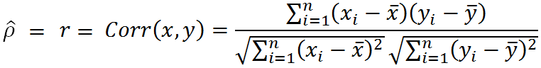

Values of *r* range between $-1$ (perfect negative correlation) to $1$ (perfect positive correlation). A value of $0$ indicates that there’s no (linear) association between $x$ and $y$.

1. ***Hypothesis tests (Pearson Correlation Coefficients)***

In general, we want to do the following hypothesis test:

$H_{0}:ρ=0$ vs.

$$H_{a}:ρ≠0$$

Let’s assume for a moment that $H_{0}$ is true and that the population correlation coefficient $ρ=0$. If we were to have many samples (each of size *n*) of variables *x* and *y*, and calculate the sample correlation *r* for each pair of samples, we could look at the distribution of the *r*’s, which might look like the graph below ([source](https://i.stack.imgur.com/fsMAY.png)). We should note a few things:

* The distribution of *r* looks like a bell-shaped curve (this is true if two variables are normal)
* The distribution is centered around 0, which is the expected value of the statistic *R* if $H_{0}$ is true. That is, $μ_{R}=ρ=0$.
* The spread of the distribution will depend on the sample size. The greater the sample size, the lower the variance.

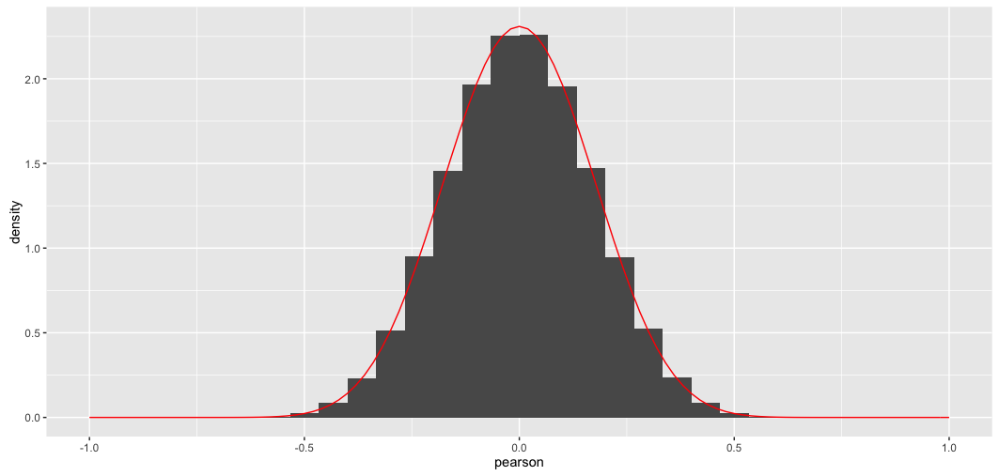

Specifically, we know that when $H_{0}$ is true, the quantity $\frac{R-μ_{R}}{s_{R}}$ has a *t*-distribution with $n-2$ degrees of freedom, where *n* is the sample size. We also know that when $H_{0}$ is true, $μ_{R}=0$, and $s_{R}=\sqrt{\frac{1-R^{2}}{n-2}}$.

Plugging everything in, we get:

$$\frac{R-μ_{R}}{s_{R}}=\frac{R-0}{\sqrt{\frac{1-R^{2}}{n-2}}}=\frac{R\sqrt{n-2}}{\sqrt{1-R^{2}}}=T \sim t_{α,n-2}$$

From this, we can also calculate the *p-value*, the probability of getting a value of *r* at least as large as the one we obtain in our sample if $H_{0}$ is true (i.e., if $ρ$, the actual value of the correlation coefficient in the population, is $0$).

1. ***Example***

Slide 30 presents a sample of $n = 10$ children. For each child, we have two variables: age and vocabulary (# of words the child knows). We can calculate the sample Pearson correlation coefficient in the R software using the *rcorr* command in the library *Hmisc* (or in Excel, using the *correl* or *pearson* functions). In our sample, $r = 0.98$.

We can also run the hypothesis test, where $H_{0}:ρ=0$ and $H_{a}:ρ≠0$:

$$\frac{R\sqrt{n-2}}{\sqrt{1-R^{2}}}=\frac{0.98\sqrt{10-2}}{\sqrt{1-{0.98}^{2}}}=12.93=T \sim t_{α,n-2=8}$$

The *rcorr* command in R automatically gives us a *p-value*. We can also calculate it in Excel using the formula $=tdist(12.93, 8, 2)$, where $12.93$ is the value of the *t*-statistic calculated above, $8$ is the degrees of freedom ($n-2 = 10-2 = 8$), and $2$ is the number of tails, corresponding to the formulation of the alternative hypothesis $H_{a}:ρ≠0$. (If the form of the alternative hypothesis were $H_{a}:ρ>0$, we would have a one-tailed test).

The *p-value* is computed to be $<0.0001$, indicating that if $H_{0}$ is true and the population correlation coefficient between age and vocabulary is $ρ=0$, then the probability of us observing a sample (of size $n=10$) where the correlation coefficient is at least $r=0.98$ is very low (i.e., $<0.0001$). That is, it’s very unlikely that this sample comes from a population where $ρ=0$. Also, because the *p-value $<0.05$* , we reject $H_{0}$ for $H_{a}$.

1. ***Spearman correlation coefficients***

Remember that Spearman correlations are simply Pearson correlations between ranked values of *x*’s and *y*’s. Thus, hypothesis tests for Spearman correlations will be essentially the same as the hypothesis tests for Pearson correlations.

A Spearman correlation of 1 results when the two variables being compared are monotonically related, even if their relationship is not linear. This means that all data-points with greater *x*-values than that of a given data point will have greater *y*-values as well. In contrast, this does not give a perfect Pearson correlation.

[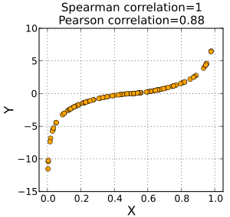](https://en.wikipedia.org/wiki/File:Spearman_fig1.svg)

Source: <https://en.wikipedia.org/wiki/Spearman%27s_rank_correlation_coefficient>.